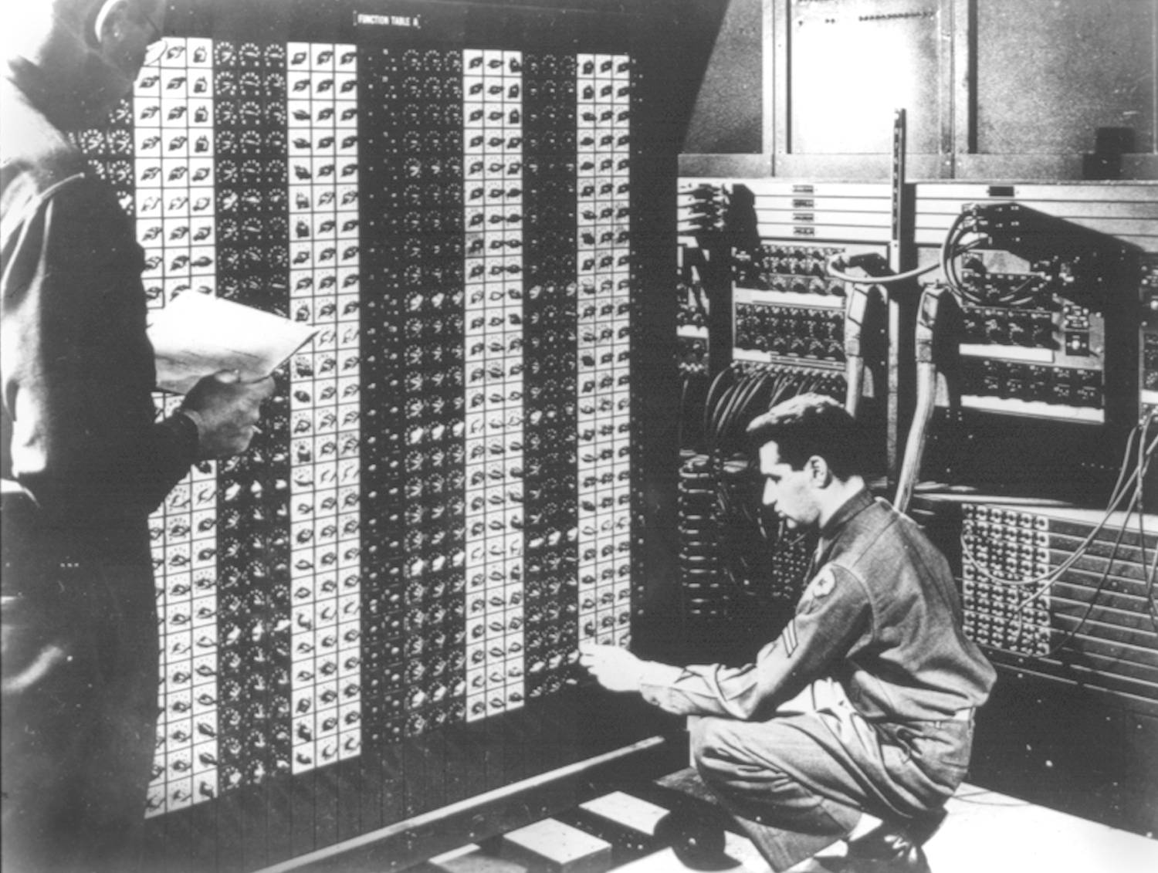 

**Advanced Placement Computer Science**

**Unit 3: Object Oriented Programming**

Lesson: Interfaces

*Last Updated: 11/12/2015*

USB is really cool, isn’t it?  
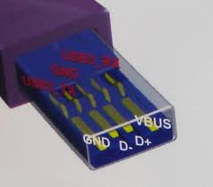 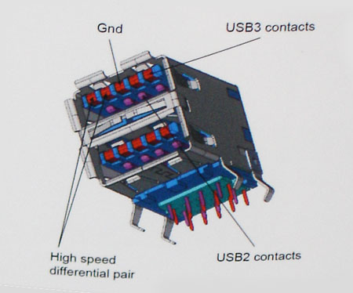

It allows us to plug a thumb drive into any computer that supports USB, and voila, after installing the device driver, you’ve got a removable drive!!!!

Java has a similar concept, **interfaces** are a collection **of methods that must be implemented by a class, a promise from programmer to programmer!**

Let’s look at a useful interface.

public interface MouseListener extends EventListener {

/**

* Invoked when the mouse button has been clicked (pressed

* and released) on a component.

*/

public void mouseClicked(MouseEvent e);

/**

* Invoked when a mouse button has been pressed on a component.

*/

public void mousePressed(MouseEvent e);

/**

* Invoked when a mouse button has been released on a component.

*/

public void mouseReleased(MouseEvent e);

/**

* Invoked when the mouse enters a component.

*/

public void mouseEntered(MouseEvent e);

/**

* Invoked when the mouse exits a component.*/

public void mouseExited(MouseEvent e);

}

All methods in an interface must be **implemented by the class that implements interface**

Differences between interfaces and classes

1. **There is NO logic or commands in an interface, only method signatures**
2. **Everything is public in an interface, nothing private**
3. **NO variables in an interface**

Interfaces guarantee that certain methods are implemented. This helps write more general purpose code.

Some popular interfaces;

|  |  |
| --- | --- |
| **Interface** | **Methods that must be implemented** |
| ActionListener | public void actionPerformed(ActionEvent blah) |
| Comparable | public int compareTo(Object o) |
| KeyListener | public void keyPressed (KeyEvent e)  public void keyTyped (KeyEvent e)  public void keyReleased (KeyEvent e) |
| MouseListener | public void mousePressed(MouseEvent event)  public void mouseClicked(MouseEvent event)  public void mouseReleased(MouseEvent event)  public void mouseEntered(MouseEvent event)  public void mouseExited(MouseEvent event) |

Now if we create a class that implements BOTH MouseListener and KeyListener, what do we know?

public class MyFrame implements KeyListener, MouseListener {

//**Must implement 3 methods from KL and 5 from MouseListener**

}

How about the Comparable interface?

You must define how to **compare two objects of your class and rank them**

Works like the mathematical operator **subtraction**

For example, String implements Comparable, so

String s1 = “CAT”, s2 = “DAD”;

int result = s1.compareTo(s2); //what is the value of result??? **Since C= 67 in ASCII, and D is 68, this method returns 67-68 which is -1**

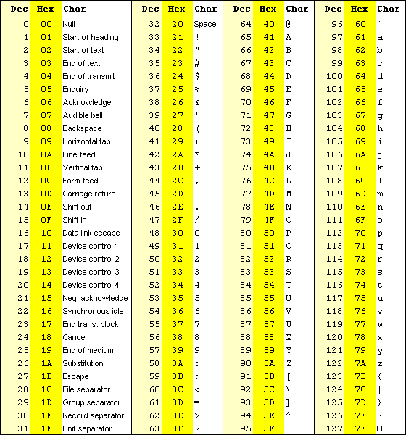  
How about “Carly”.compareTo(“Allen”); **67-65 which is 2**

How about “Eric”.compareTo(“Erin**”); E’s are same so we go to r versus r same so i versus i same so c versus n** **99-114 which is -15**  
  
How about “Sanjee”.compareT0(“Sanjee”); **0**

How about “tea”.compareTo(“teapot”); **0-112 = -112**

Summary: **0-112 = -112**  
  
What does this allow us to do with Strings?

**This allows us to compare strings alphabetically in English and sort them(NOTE: all UPPERCASE comes before all lowercase and space is ascii 32 so it is below them all)**

Furthermore, there is a method **Collections.sort** which will sort any ArrayList of Comparables  
  
ArrayList<String> namesAL = new ArrayList<String>();

namesAL.add("Cara");

namesAL.add("Carly");

namesAL.add("Bob");

namesAL.add("Austin");

namesAL.add("Zoe");

namesAL.add("Jessica");

Collections.sort(namesAL);

for (int i = 0; i < namesAL.size(); i++) {

System.out.println(namesAL.get(i));

}  
  
//OUTPUT  
Austin

Bob

Cara

Carly

Jessica

Zoe

How about a TennisPlayer class that implements Comparable?

import java.util.Date;

public class TennisPlayer implements Comparable {

private String lastName, firstName, countryOrigin;

private Date dob;

private int rank, annualEarnings, tourPoints;

public int getRank() { return rank; }

public int compareTo(Object other) {

TennisPlayer oth = (TennisPlayer) other; //must TYPECAST when using compareTo

return rank – oth.getRank();

}

}

**How do we use this to test 2 players?**

public class Tester {

public static void main(String args[]) {

TennisPlayer rafa = new TennisPlayer(“Nadal”, “Rafael”, “Espana”, new  
 Date(1986,6,3), 5, 583074, 6675);

TennisPlayer roger = new TennisPlayer(“Federer”, “Roger”, “Switzerland”, new  
 Date(1981,8,18), 3, 550,017, 5205);

//Write the logic to compare the two players

**if(rafa.compareTo(roger)==0){**

**System.out.println(“Equal”);**

**}  
 else if(rafa.compareTo(roger)<0){  
 System.out.println(“Rafa ranked lower number”);  
 }  
 else {  
 System.out.println(“Rafa ranked higher number”);  
 }**

}

}

**Interfaces can also be passed as parameters to a method.**

/**

* The <code>AudioClip</code> interface is a simple abstraction for playing a sound clip. Multiple

* <code>AudioClip</code> items can be playing at the same time, and the resulting sound is mixed together to

* produce a composite.

* @author Arthur van Hoff

* @since JDK1.0

*/

public interface AudioClip {

/**

* Starts playing this audio clip. Each time this method is called,

* the clip is restarted from the beginning. */

void play();

/**

* Starts playing this audio clip in a loop. */

void loop();

/**

* Stops playing this audio clip.*/

void stop();

}

Write a method called playIntro that takes in an AudioClip (ac)reference and plays it as the intro to a program  
**public void playIntro(AudioClip snd) {  
 snd.play();  
}**